Practical - 9
NAME: TASNEEM SADIKOT
PRN: 2300521162

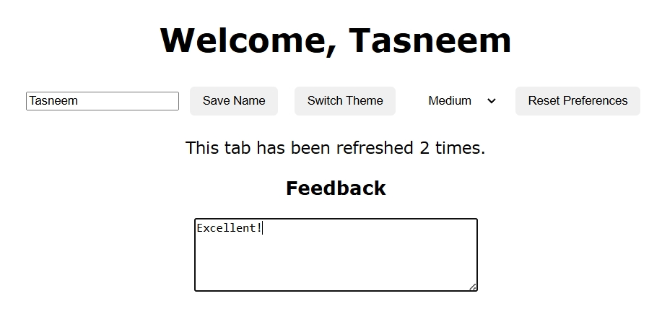
<!DOCTYPE html>
<html lang="en">
<head>
<meta charset="UTF-8">
<title>Personal Dashboard</title>
<style>
body {
font-family: Verdana, sans-serif;
transition: all 0.4s ease;
text-align: center;
padding: 20px;
}
.dark { background-color: #121212; color: white; }
.light { background-color: #ffffff; color: black; }
#controls button, select {
margin: 6px;
padding: 8px 14px;
border: none;
border-radius: 5px;
cursor: pointer;
}
</style>
</head>
<body>
<h1 id="welcomeText">Welcome!</h1>
<div id="controls">
<input type="text" id="userName" placeholder="Enter your name">
<button id="saveUser">Save Name</button>
<button id="themeBtn">Switch Theme</button>
<select id="fontChooser">
<option value="small">Small</option>
<option value="medium">Medium</option>
<option value="large">Large</option>
</select>
<button id="resetPrefs">Reset Preferences</button>
</div>
<p id="tabCounter"></p>
<h3>Feedback</h3>
<textarea id="feedback" rows="5" cols="40" placeholder="Your feedback..."></textarea>

<script>
/* Task 1 – Fix Theme Storage */
const THEME_KEY = "theme";
let themeNow = localStorage.getItem(THEME_KEY) || "light"; // default = light
document.body.className = themeNow;

document.getElementById("themeBtn").onclick = function() {
const newTheme = document.body.classList.contains("light") ? "dark" : "light";
document.body.className = newTheme;
localStorage.setItem(THEME_KEY, newTheme);
};

/* Task 2 – Repair Font Size Logic */
const FONT_KEY = "fontsizePref";
const fSelect = document.getElementById("fontChooser");
const fontMap = { small: "14px", medium: "18px", large: "22px" };

fSelect.onchange = function() {
const f = fSelect.value;
document.body.style.fontSize = fontMap[f];
localStorage.setItem(FONT_KEY, f);
};
let storedFont = localStorage.getItem(FONT_KEY);
if (storedFont) {
document.body.style.fontSize = fontMap[storedFont];
fSelect.value = storedFont;
}

/* Task 3 – Username Greeting */
const USER_KEY = "username";
const nameInput = document.getElementById("userName");
const welcomeText = document.getElementById("welcomeText");

document.getElementById("saveUser").onclick = function() {
const user = nameInput.value.trim();
if (user) {
localStorage.setItem(USER_KEY, user);
welcomeText.innerText = "Welcome, " + user;
}
};

const savedName = localStorage.getItem(USER_KEY);
if (savedName) {
nameInput.value = savedName;
welcomeText.innerText = "Welcome, " + savedName;
}

/* Task 4 – Session Counter */
let count = Number(sessionStorage.getItem("visits")) || 0;
count += 1;
sessionStorage.setItem("visits", count);
document.getElementById("tabCounter").innerText =
`This tab has been refreshed ${count} ${count === 1 ? "time" : "times"}.`;

/* Task 5 – Feedback Restoration */
const fb = document.getElementById("feedback");
const FB_KEY = "feedbackText";

const savedFeedback = sessionStorage.getItem(FB_KEY);
if (savedFeedback) fb.value = savedFeedback;

fb.addEventListener("input", () => {
sessionStorage.setItem(FB_KEY, fb.value);
});

/* Final Task – Reset Preferences */
document.getElementById("resetPrefs").onclick = function() {
localStorage.clear();
location.reload();
};
</script>
</body>
</html>

